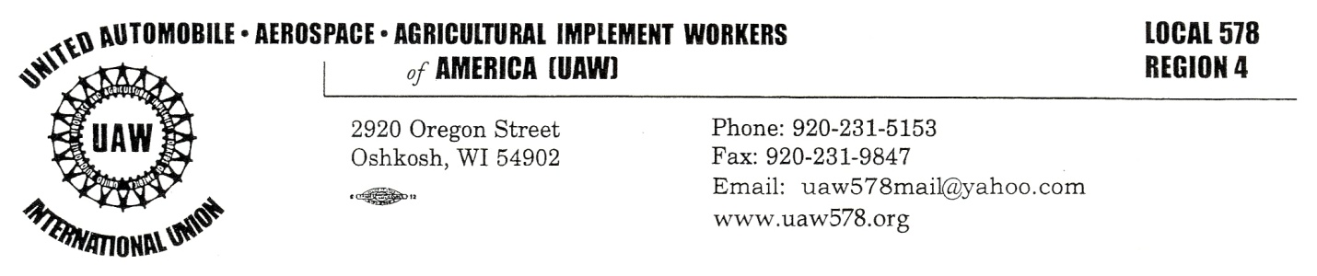

February 10, 2023

Sisters, Brothers, and Union Family of UAW Local 578,

Our great UAW Local 578 continues to be a strong backbone of working people in our community!

By now, you have likely all heard that the JLTV Phase II will not be performed in Oshkosh. It was awarded yesterday to a different company. Myself, our Executive Board, Bargaining Committee, and stewards share equal frustration. We build the best and support the best. We always have and will continue to do so!

Over the last few years, we have relied heavily on the funds awarded to our area and the work afforded our people due to the continued awarding of DOD funding on a variety of products our people have built to support the war-fighter in every possible way.

We hope to continue discussions as we all learn more as to exactly what this means, along with any possible impacts on our people. We will keep you updated as we learn more. We do know that we have 18 months left on our current JLTV contract and other work coming in.

I politely ask everyone to remain as calm as possible (emotions will be running high). Please be decent to each other. Our entire Union is built upon people coming together as one with a common goal.

In Solidarity,

Bob Lynk
President
UAW Local 578

