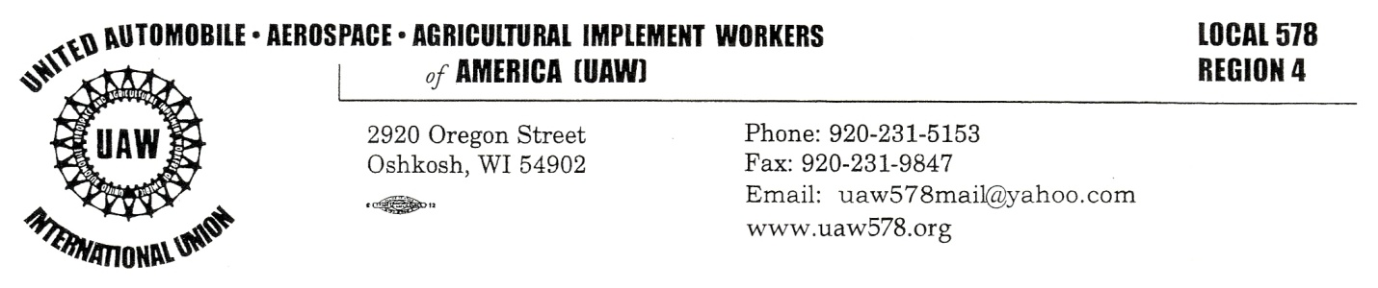
April 9, 2020
To All Members of UAW Local 578:

Hello, Brothers and Sisters! I hope this message finds you and your family safe. These are just crazy and unprecedented times. COVID-19 has really put our lives in a different spot. None of us know for sure what lies ahead. I want to get something out to each and every one of the members of our great Union, UAW Local 578. There is a lot going on. I’ll be sharing many thoughts in this correspondence.

Our Union has stood strong for our members and community since 1938 when we first chartered. This is more important now than at any other time in our existence. We need one another, our community needs us, and we need our community!

All our members and their families are essential. It doesn’t take any virus or catastrophe for me to know that! Essential seems to be some new “hook” word being used in excess nowadays, but you have always been and always will be essential to our Union and the brave men and women of the United States military.

Perhaps you know someone who is struggling right now to feed their family. Perhaps you know someone who feels more isolated now than they ever had. Perhaps you know someone who is lonely, living in fear or lacking support. I encourage each of our members to be mindful.

If you or anyone you know needs non-medical assistance, call 211 from any phone. Our local food banks need assistance as demand has surged over the past couple weeks due to the large amount of new unemployment claims being filed.

There are many ways we can stay connected with loved ones and stay social with them other than having crowds. Please do that. What you do outside of work can affect us all while at work.

There are a couple of websites that also can help us stay informed of Corona Virus and COVID-19 in Wisconsin and our country. Some that I find helpful are:

dhs.wisconsin.gov/covid-19
cdc.gov/coronavirus/2019ncov
cdc.gov/coronavirus

As always, myself and our committee, board, stewards, and reps will continue to monitor the concerns and complaints of our members. If there is something going on that you feel we should bring up to management, please keep informing us. We will continue to stay in communication.

We will get through this together!

In Solidarity,

Bob Lynk
President/Bargaining Chair
UAW Local 578

